Press Release

Smap3D Summit 2026: New industry event for plant manufacturers and pipe producers
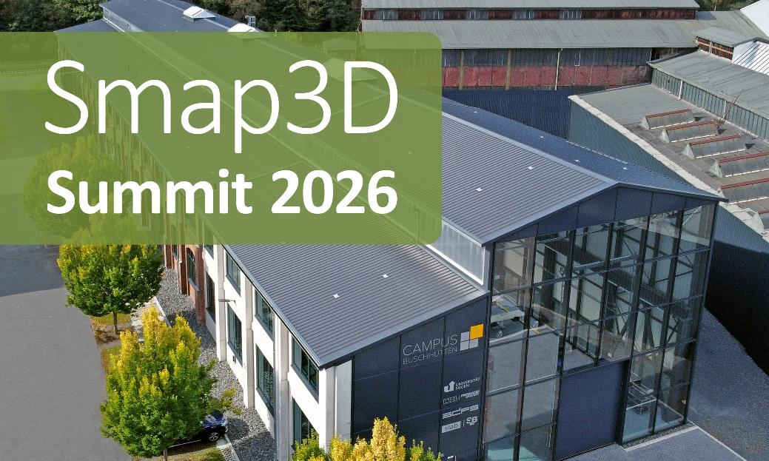
The Smap3D Summit will take place for the first time in September 2026 and is set to become a regular industry gathering. (Image: Campus Buschhütten)
Nittendorf, February 18, 2026
On September 30, 2026, the international software provider Smap3D GmbH will host the first “Smap3D Summit 2026” at the Campus Buschhütten in Kreuztal near Siegen, Germany. With this new event format, the company aims to establish an annual industry platform for the engineering and manufacturing of pipes and piping systems in mechanical and plant engineering.
The summit is aimed at experts in plant design and pipe production from Europe. The focus is on end-to-end processes – from engineering to the fabrication of pipes and piping systems. In addition to existing customers, interested parties are also expressly invited to attend. Participation is free of charge, but places are limited. “With the Smap3D Summit, we are creating a central platform for professional exchange on modern pipeline engineering and pipe manufacturing,” explains Maxim Lich, Managing Director of Smap3D GmbH. “Our goal is to showcase the unique expertise of our network, highlight technological possibilities and developments, and establish an open exchange between experts, users, and industry colleagues.”
Live technology and specific use cases
The program combines practical presentations by customers and partners with live demonstrations (live sessions) of software and hardware solutions for engineering and fabrication. In topic-specific “breakout sessions,” experts explore technical issues and challenges in small groups. Another focus is on insights into the strategic roadmap of Smap3D: Participants will gain an insight into future developments in CAD-integrated software solutions for pipeline engineering. With the presence of the Connected Pipeshop Alliance partners and other solution providers, Smap3D is underlining its ecosystem strategy. The aim is to integrate engineering and fabrication more closely in terms of technology and to offer users a consistent, practice-oriented system landscape.
More information about the Smap3D Summit can be found at www.smap3d.com/en/smap3d-summit-2026.
(2,069 characters including headings, with spaces)

About Smap3D GmbH
Smap3D offers turn-key software solutions for engineering and fabrication. The company covers the entire process chain, from process engineering (P&ID) through piping planning (3D Piping) and Isometric, to production planning and control. Modules for steel construction and for the conversion of point cloud data (3D Laser scanning) round out the portfolio. The solutions can be completely integrated into the most common CAD systems in use in industry, Solid Edge, SolidWorks and Inventor, enabling turn-key plant engineering. With headquarters in Germany as well as worldwide offices and partners, Smap3D has distinguished itself through many years of expertise in plant planning and construction. The team provides assistance and advice to customers and partners, from consulting and implementation to training and technical support. This continuous process in all phases of product development has been proven in companies from many different industries, including process industry (e.g. chemical, beverage, food, pharmaceutical), environment and water technology.

Website
www.smap3d.com/en

Social Networks
LinkedIn: www.linkedin.com/company/smap3d-gmbh
Facebook: www.facebook.com/Smap3DGmbH
YouTube: www.youtube.com/@Smap3DGmbH

Contact
Smap3D GmbH
Katrin Ehrenleitner, PR Marketing Manager
Am Marktplatz 7, 93152 Nittendorf, Germany
Tel.: +49 9404 9639-41
kehrenleitner@smap3d.com

